Lab 7 - Intro to Vue

**0. Install:** install Vue dev tools extension for Chrome <https://github.com/vuejs/vue-devtools>.

Go to <chrome://extensions/> and look for the Allow access to file URLs toggle, turn this on.



**1. Code from slides, 10 points:**

Make sure all of the apps from the slides work:

* The Hello Vue app,
* Hello app with the button that adds !!!!
* Hello app with the button that adds !!!! and uppercase filter
* **Hello app that limits the number of exclamation points to 10**
* The enter-your-name form, the one with the v-if directive that only displays a message if a name is entered
* The shopping cart with the computed property and filter

**2. Property or method ... is not defined on the instance but referenced during render.  5 points**

What does this Vue error message mean? What causes it, and how do you fix it?

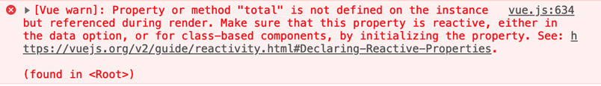

**It means that the total property was not declared in the Vue statement but accessed in the javascript section. You can fix this by adding total within New Vue{…total:…}**

**3. Vue developer tools, 5 points**

Make sure you've installed Vue dev tools. Take a screenshot of the shopping cart app showing the dev tools running, and **showing the data** for any one of your apps.

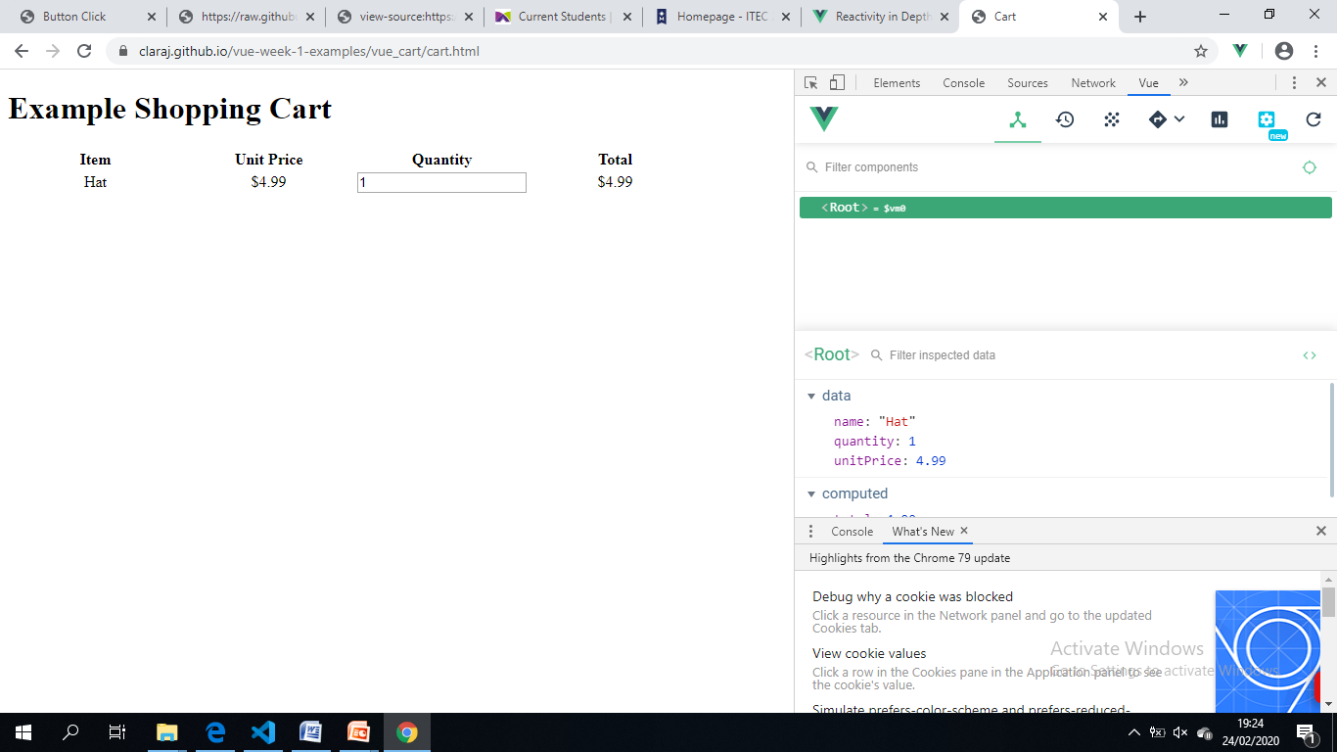

Add the code for all of your apps, a **TEXT** file with your answer to Q2, and the Vue dev tools screenshot, to a git repository and push to GitHub.

**To submit:**

Your GitHub repository links.  No zip files.